“Faith Promise Giving” – Also known as “Grace Motivated and Empowered Giving”
Purpose of Slide: Emphasize the power of teaching Faith Promise Giving.
The Main Thing: This is the most effective way to involve people in personalizing the act of giving.

Trainer’s Notes:
- The People’s Church in Toronto moved up to giving 50% of their total revenue to missions through this process.
- Dr. Foltz’ home church gave 33% of their total revenue through this process.
- This is a biblical, tested, and proven methodology.
_____________________________________________________________________
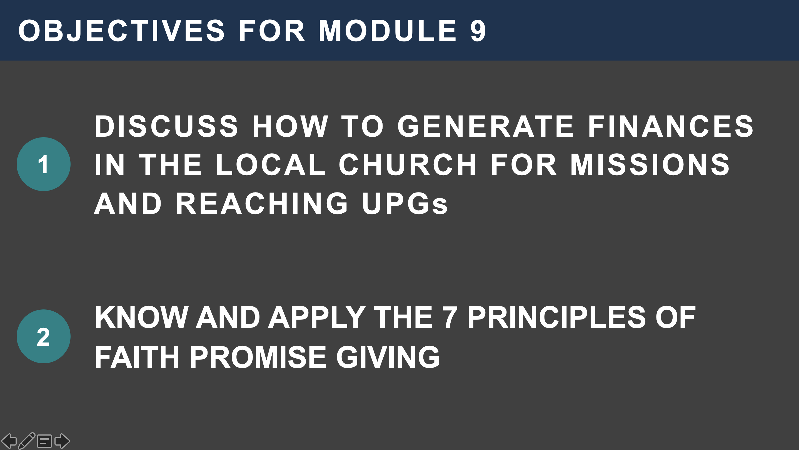
Purpose of Slide: Present the objectives for Module 9 – Faith Promise Giving.
The Main Thing: Everything we have belongs to Him, it came from God. Everything comes from God – even our every breath.

Trainer’s Notes:
- Objectives for Module 9:
- Describe how to generate financial provision in the local church for missions and reaching UPGs.
- Know and apply the 7 Principles of Faith Promise Giving.
_____________________________________________________________________

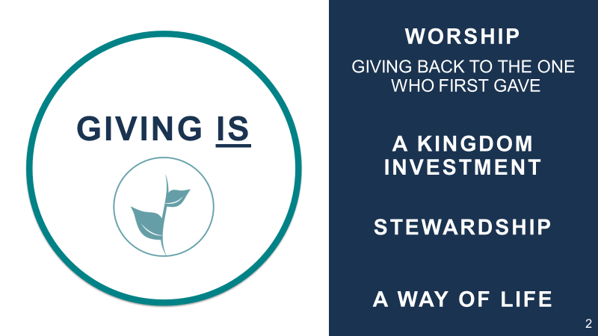
Purpose of Slide: Giving is an act of worship and God is the principal model of a giver.
The Main Thing: Everything we have belongs to Him, came from God. Everything comes from God even our every breath.
Trainer’s Notes: Giving is:
- Worship – Giving back to the Lord, who gave first.
- A Kingdom Investment.
- Stewardship of God’s provision to us.
- A way of life – Our way of life should be honoring God, listening to Him, and stewarding our blessings.

_____________________________________________________________________

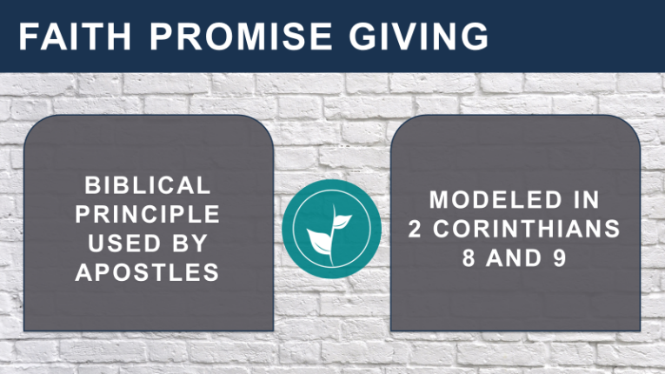
Purpose of Slide: This teaching is modeled by the Apostles.
The Main Thing: Seven important principles will follow.

Trainer’s Notes:
- Modeled by the Apostles in
2 Corinthians 8-9:
- The church in Jerusalem was experiencing famine, and apostolic teams were sent throughout the churches to receive offerings and take faith promises.
- The faith promises would be collected, then the Apostles would return to receive them and get these funds to Jerusalem.
- NOTE:
- One verse in every six in the first three Gospels relate, either directly or indirectly, to money.
- Sixteen of our Lord’s parables deal with the use or misuse of money.

_____________________________________________________________________

Purpose of Slide: Describe what Faith Promise Giving is not.
The Main Thing: Eliminate confusion about Faith Promise Giving.

Trainer’s Notes:
- Grace giving is not these four things:
- The tithe – returning to God what is already His.
- A commitment to be followed up by another person.
- A foolish promise, but a commitment based on communication with God.
- Something to boast about - “Look what I have done,” but “Behold what God has done!”
- William Carey said, “I was once young and now I am old, but not once have I been witness to God’s failure to supply my need when first I had given for the furtherance of His work. He has never failed in His promise, so I cannot fail in my service to him.

_____________________________________________________________________

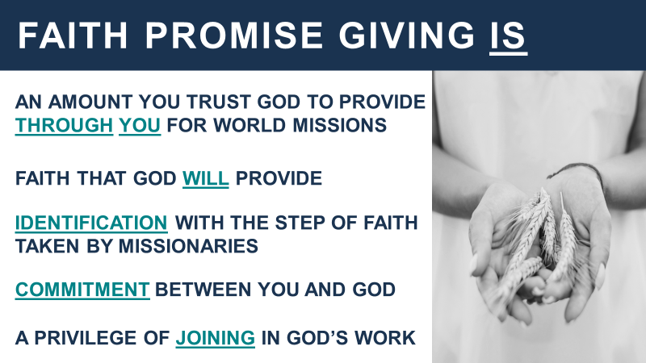
Purpose of Slide: Describe the basis of Faith Promise Giving.
The Main Thing: Clearly state what Faith Promise Giving is

Trainer’s Notes:
- Grace giving is:
- An amount you trust God to provide through you for world missions.
- A step of faith that God will provide.
- An identification with the step of faith taken by missionaries.
- A commitment between you and God.
- A privilege of joining in God’s work.
- Give personal support raising testimony.
OR
- Testimony: Many years ago, ill health compelled the two missionaries stationed at Efulan (in Africa) to return to America, leaving but six believers, for the station had only been open a short time.
- They dared not hope they would find any Christians on their return two years later, for how could six recent converts stand alone in an African village? They found, however, that the small group had met several times every week for prayer and Bible study and had witnessed and given so faithfully for Christ that all the neighboring villages knew that they were "Jesus men."
- Is it any wonder, then, that the church grew into a great congregation and that, on the 25th anniversary of its organization, 7000 people assembled for a communion service in which the sacrament was celebrated by three African ministers—the bread and wine distributed by 24 native elders?
- THEY SOWED – GOD GAVE THE INCREASE.
_____________________________________________________________________

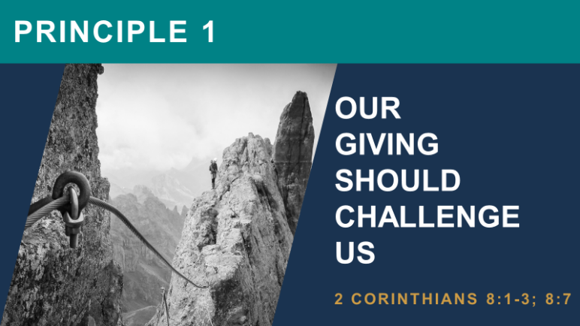
Purpose of Slide: Principle #1 – Giving is part of being a growing disciple.
The Main Thing: Emphasize the power of the biblical, apostolic model – it will work in our contemporary experience.
Trainer’s Notes:
- Bishop Fulton J Sheen said, “Never measure your generosity by what you give, but rather by what you have left.”
- 2 Corinthians 8:1-3 (NIV) – “… We want you to know about the grace that God has given the Macedonian churches. In the midst of a very severe trial, their overflowing joy and their extreme poverty welled up in rich generosity. …They gave as much as they were able, and even beyond their ability.”
- 2 Corinthians 8:7 (NIV) – “But since you excel in everything… see that you also excel in this grace of giving.”
- This teaching not only worked in Ethiopia and Malaysia, but multiple times in India as well
- Dr. Foltz was teaching 160 pastors about Faith Promise Giving and discovered that they were not even teaching tithing.
- At first, they resisted this teaching, but God broke their “poverty mentality” and they responded with generosity.
- They adopted five UPGs, raised faith promises to plant house churches in their midst, and even raised funds to send one of their own Indian missionaries to Bangladesh.

_____________________________________________________________________

Purpose of Slide: Principle #2 – Faith Promise Giving comes out of our covenant relationship with God.
The Main Thing: God covenanted with His children, giving them the ability to produce wealth.
Trainer’s Notes:
- Deuteronomy 8:18 (NIV) – “But remember the Lord your God, for it is He who gives you the ability to produce wealth, and so confirms His covenant, which He swore to your ancestors, as it is today.”
- Emphasize the Hebrew word koach.
- This word, and principles behind it, is how all wealth is produced.
- Koach is the foundation of developing societies and it comes from the image and likeness of God given to humanity in creation.
- Koach means the following:
- Power
- Create
- Innovate
- Strength
- Capacity
- “Giving is more than a responsibility — it is a privilege; more than an act of obedience — it is evidence of our faith.” William Arthur Ward
- Emphasize Koach again. This the sealing of our relationship with God.

_____________________________________________________________________

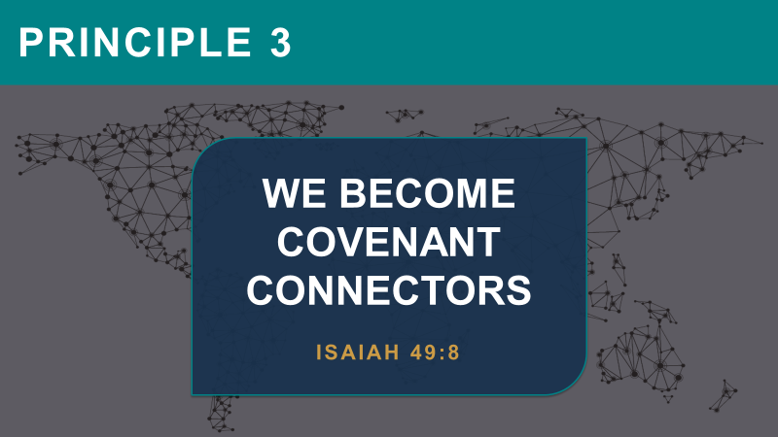
Purpose of Slide: Principle #3 – God makes us to be a covenant people for the lost.
The Main Thing: Out of our covenant relationship with God, He wants us to be “covenant connectors” with those who have never heard the gospel.

Trainer’s Notes:
- Isaiah 49:8 (NIV) – “... This is what the Lord says: “In the time of my favor I will answer you, and in the day of salvation I will help you; I will keep you and will make you to be a covenant for the people, to restore the land and to reassign its desolate inheritances…”
- Our relationship with God in Faith Promise Giving allows us to partner with missionaries and national churches to “restore the land and reassign it’s desolate inheritances.” This refers to seeing the unreached come out of darkness into light.

_____________________________________________________________________

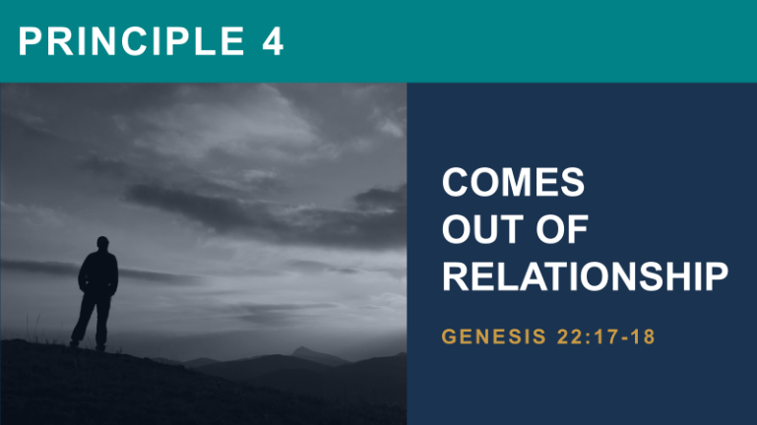
Purpose of Slide: Principle #4 – Obedience ushers us into relationship with God.
The Main Thing: Our obedience demonstrates our love and relationship with God.
Trainer’s Notes:
- Genesis 22:17-18 (NIV) – “I will surely bless you and make your descendants as numerous as the stars in the sky and as the sand on the seashore. Your descendants will take possession of the cities of their enemies, and through your offspring all nations on earth will be blessed, because you have obeyed me.”
- Abraham was tested in his commitment to God. He responded with obedience that brought forth the revelation of “the God who provides.”
- Abraham and his lineage became a fountain of blessings to the nations, as a missionary people.
- For God’s blessings to flow, just like for Abraham, we must:
- Make a commitment to our faith in Jesus.
- Consistently demonstrate obedient faith.
- Assure our faith is an accurate witness to Jesus to unbelievers.

_____________________________________________________________________

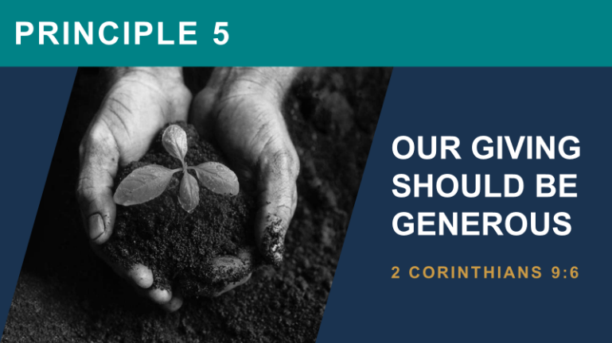
Purpose of Slide: Principle #5 – Our giving should be generous.
The Main Thing: This passage speaks of the law of sowing and reaping. To sow sparingly is to reap sparingly. To sow bountifully is to reap bountifully. The secret is SOWING!
Trainer’s Notes:
- 2 Corinthians 9:6 (NIV) – “Remember this: Whoever sows sparingly will also reap sparingly, and whoever sows generously will also reap generously.”
- Important Illustration: William Sloane Coffin
- In the Holy Land are two ancient bodies of water. Both are fed by the Jordan River. In one, fish play and roots find sustenance. In the other, there is no splash of fish, no sound of bird, no leaf growing.
- The difference is not in the Jordan, for it empties into both, but in the Sea of Galilee: for water taken in also goes out. It gives and lives.
- The other gives nothing. And it is called the Dead Sea.”
- We must have a vision for harvest. There is nothing wrong with a farmer looking earnestly to God to bring forth a harvest from his hard work of sowing seed. Even so, we are exhorted to have an expectation that God will bless and bring forth a spiritual harvest. Therefore, sow as much as you can! Do you want to have a tremendous, valuable harvest? It will never happen if plenty of seed has not been sown.
- If you eat your seed, you will never see a harvest!
_____________________________________________________________________

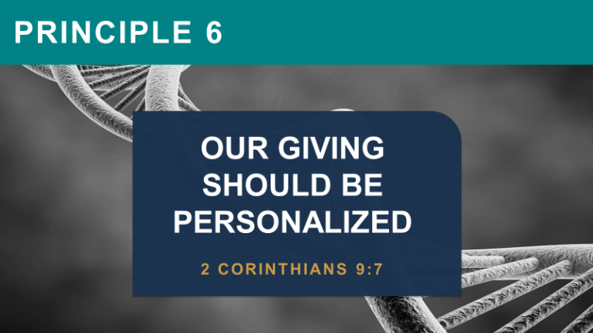
Purpose of Slide: Principle #6 – Giving should be personalized.
The Main Thing: The power behind Faith Promise Giving is that it helps personalize the Great Commission in the life of each believer. Each believer must decide in his heart how he/she will respond as a giver.
Trainer’s Notes:
- 2 Corinthians 9:7 (NIV) – “Each of you should give what you have decided in your heart to give, not reluctantly or under compulsion, for God loves a cheerful giver.”
- Giving is to be purposeful, not haphazard. "Let each one do just as he has DECIDED in his heart," writes the apostle.
- How do your giving habits compare with this commandment? Do you "suddenly remember" when offering is taken, that you should give something? This verse speaks of making giving the top line on our budgets, not an unexpected, nuisance expense. And so, it should be with us.
- Let us note that "regular, faithful, monetary giving" is to be with a settled purposefulness; not a mere afterthought.
- Our giving should be personalized giving.
- Our hearts should lead us in giving.
- We should never give under compulsion.
- We should always give cheerfully.
- Dr. Foltz saw this happen in Malaysia. After the first teaching on Faith Promise Giving, businessmen approached the elders of the church and said, “Give us another chance – we were not ready.”
- An African girl came to America to study in a university. She arrived on Saturday and went to church on Sunday. They were taking an offering and receiving faith promises for missions, but she had no money in her possession. She stood and said, “On my second day in America I re-commit my life to follow Jesus.” She stood, placed the offering plate in the aisle and put her foot in it. “My whole life is an offering to God.”
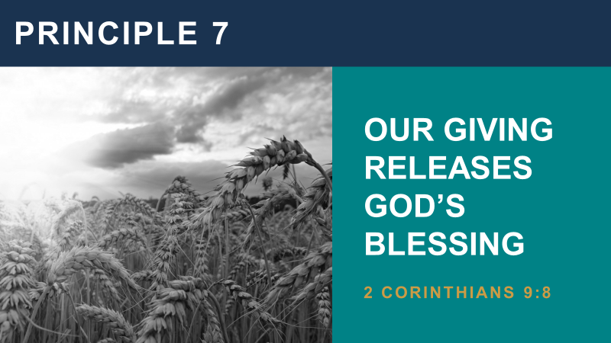
Purpose of Slide: Principle #7 – Cause and effect – giving releases God’s blessings.
The Main Thing: The power behind Faith Promise Giving is that it helps personalize the Great Commission in the life of each believer.
Trainer’s Notes:
- 2 Corinthians 9:8 (NIV) – “And God is able to make all grace abound to you, so that in all things at all times, having all that you need, you will abound in every good work.”
- This verse shows us of God's bounty and His ability to bless.
- What do we possess that we did not receive from God?
- Moreover, He supplies abundantly in order that we may be able to give to others! There is no need to worry that giving worshipfully so that others may benefit will impoverish the faithful giver.
- God will undertake to make sure that a sower looking to Him for the harvest – a purposeful, cheerful giver – will always have enough means to be able to continue to give!
- He makes all grace abound to us.
- He gives us all we need.
- He causes us to abound to every good work.
- Each believer needs to decide in his heart how he/she will respond as a giver.

_____________________________________________________________________

Purpose of Slide: Ask the people to make a personal commitment.
The Main Thing: If one first gives himself to the Lord, all other giving is easy.
Trainer’s Notes:
- Ask the people to pray over their faith promise card (see Student Outline, Strategy Exercise page 17).
- There are normally two amounts that will come to their mind
- One is a “no brainer” that they can easily give.
- But the other is a supernatural amount that requires God to work in and through them with fresh supply.
- The latter is the amount we want them to write down on their card.
- Remind them that this is between them and God and not the church or organization.
- God will supply, and if they happen to have missed what God wanted them to commit, He will use this as a learning experience to guide them in the future.
- When you are doing training, here is a great application for teaching Faith Promise Giving:
- Give each participant a Faith Promise Commitment Form. Ask each participant to pray asking God for the amount that He would ask them to trust Him for every month. Ask them to write the amount down on the form provided.
- Add up the number of Faith Promise Commitment Forms that you receive; add the total amount of the Faith Promises; divide the total amount of Faith Promises by the number of forms received, and you will have an average amount per participant.
- Ask each participant to estimate (close guess) the number of giving units in their church. A giving unit is either a single wage earner or a family.
- Calculate the total amount of income received from Faith Promises if only one-half of the giving units participated with the average amount.
- Customarily, this amazes the participants, and they begin to envision the potential of an active Faith Promise program.
_____________________________________________________________________

Purpose of Slide: Making a Faith Promise Commitment.
The Main Thing: Learn how to properly complete this form.

Trainer’s Notes:
- Ask the people to pray over their Faith Promise Commitment card.
- There are normally two amounts that will come to their mind:
- One is a “no brainer” that they can easily give.
- But the other is a supernatural amount that requires God to work in and through them with fresh supply.
- The latter is the amount we want them to write down on their card.
- Remind them that this is between them and God; not the church or organization.
- God will supply, and if they happen to have missed what God wanted them to commit, He will use this as a learning experience to guide them in the future.
- Follow instructions and turn in the form when completed.
- Be sure to tear off and keep the right side of the form for your records.

_____________________________________________________________________

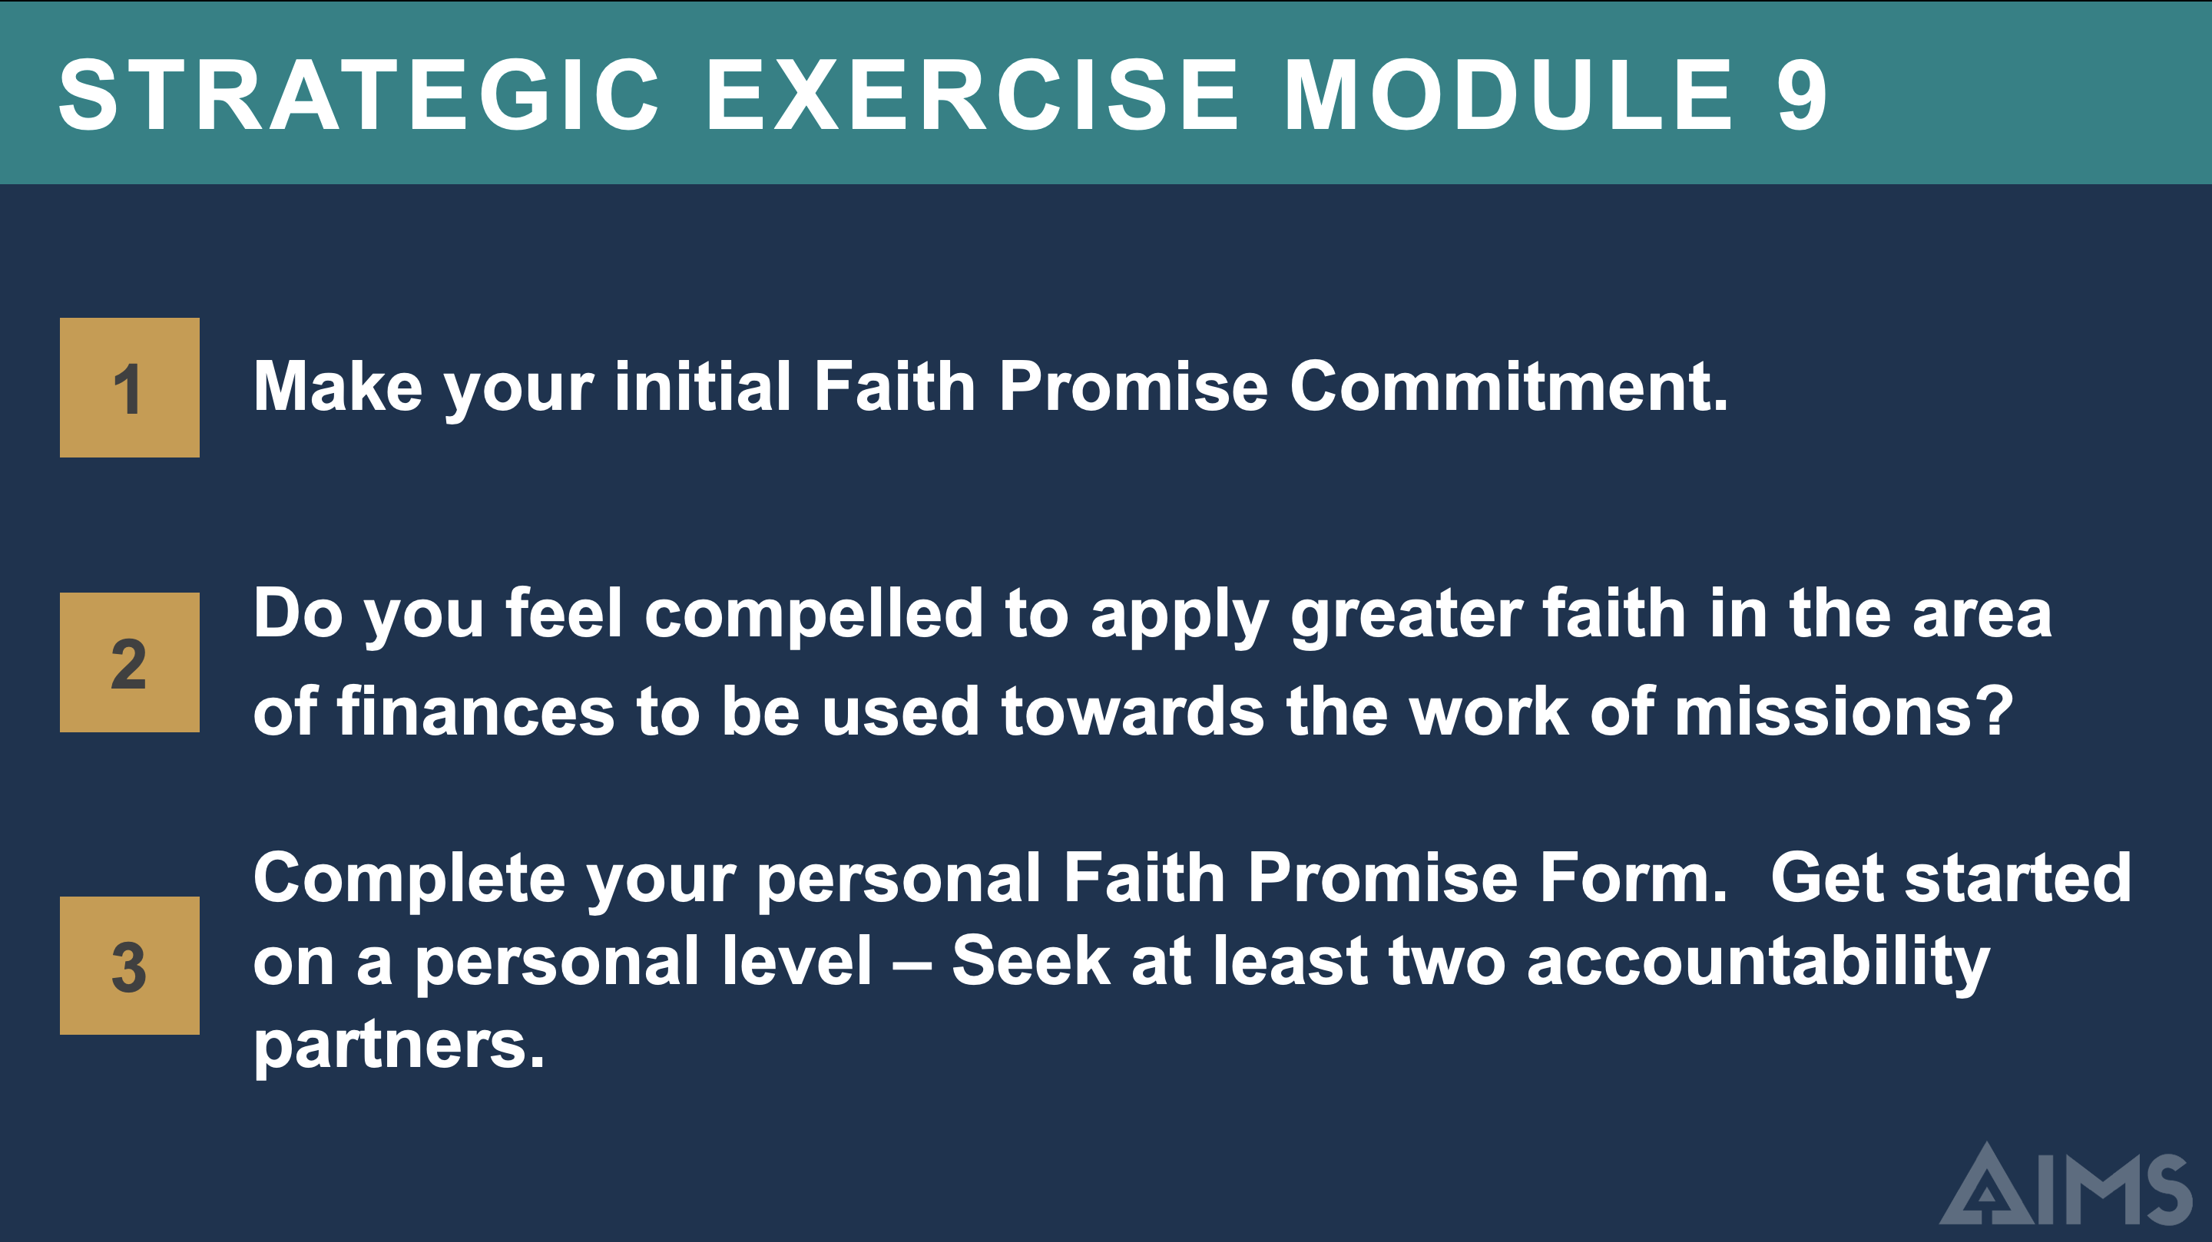
Purpose of Slide: Introduce the Strategic Exercise for Module 9.
The Main Thing: Make your initial Faith Promise Commitment.

Trainer’s Notes:
- Strategic Exercise:
- Do you feel compelled to apply greater faith in the area of finances to be used towards the work of missions?
- Complete your personal Faith Promise Form (Strategy Exercise page 17). Get started on a personal level.
- Identify and activate two or more people (spouse, family member, pastor, friends, etc.) to hold you accountable to fulfill this commitment – you might even get them involved through your testimony and connect them to AIMS.

_____________________________________________________________________

