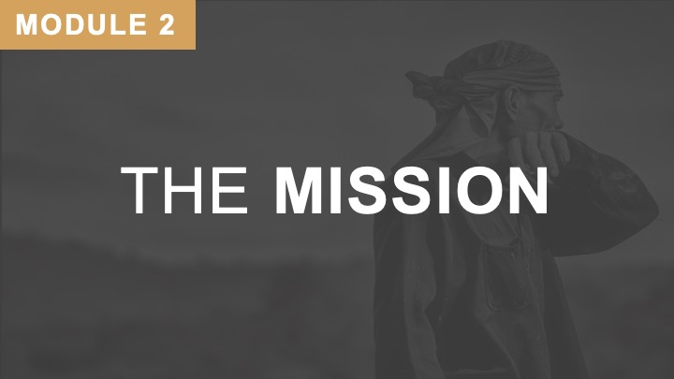
Purpose of Slide: Missions is rooted in God’s nature and seen throughout the Bible.
Main Thing: Without an understanding that God is a God of Mission and that we are people of mission, theology (without the Biblical Basis of Missions) can lead us astray and even into selfishness.
Trainer’s Notes:
- We agree with the German Theologian Rahner: “Missiology (the study of missions) is the mother of all theology.”
- We want a Biblical Basis of Missions that brings us into unity with the God of mission.
_____________________________________________________________________

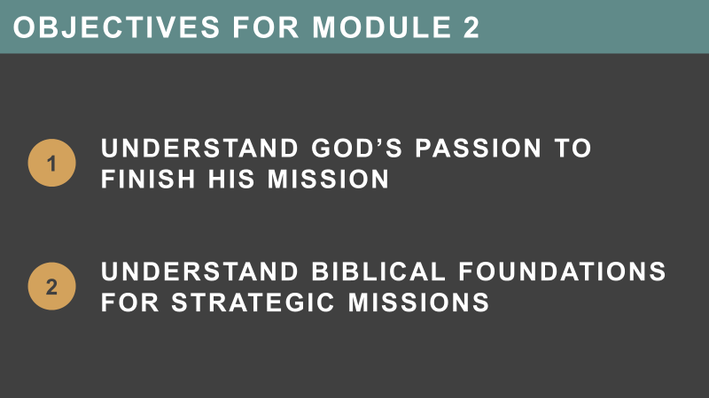
Purpose of Slide: Present the objectives for Module 2.
Main Thing: God is a God of Mission and His passion is to see His mission finished. We need to be people of passion and committed to partner with God in finishing the Great Commission.
Trainer’s Notes:
- God is a God of Mission:
- Understand God’s passion to finish His mission.
- Thoroughly understand the Biblical foundations for strategic missions.
_____________________________________________________________________

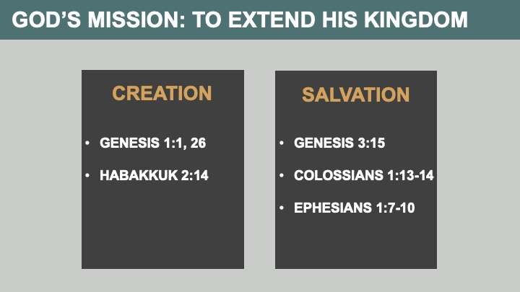
Purpose of Slide: God’s mission is to extend His kingdom. He extends his kingdom through creation and redemption.
Main Thing: God initiated mission through creation; man fell into sin, but God has provided redemption for mankind.
Trainer’s Notes:
- Basics: God is Creator, Architect, Designer; man is the image and likeness of God; the apex of God’s creation.
- Introducing the concept of mission as found in creation – the idea behind Genesis 1:1, 26 is “God created to have a Kingdom.”
- The language in this creation narrative is KINGDOM language. Explain that the Kingdom is not a type of theology or church movement but that it is the RULE and REIGN of God on the earth (much like what we see in the Lord’s prayer, “Your Kingdom come, your will be done…”).
- Our secondary scripture from Habakkuk 2:14 is to show us that the passion and plan of God has never changed (i.e. the fall of man did not change the goal of His glory and His Kingdom covering the earth). In this, man is obviously a partner via his stewardship. Knowledge in the Hebrew refers to “experiential knowledge.”
- It is this language that CONNECTS the Great Commission mandate from Genesis to Revelation. It is further defined in the mission of Redemption. The mission of redemption – is more intuitive and needs no explanation, because most understand the missions mandate in terms of redemption.
_____________________________________________________________________

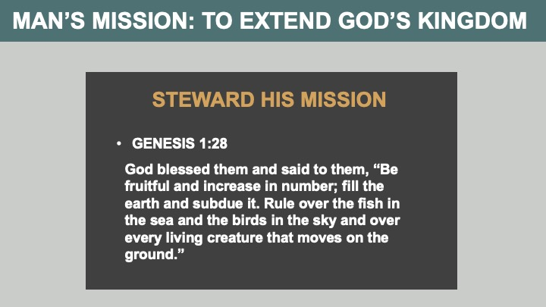
Purpose of Slide: God’s passion is revealed in His mission.
Main Thing: God initiated mission through creation; man fell into sin, but God has provided redemption for mankind. Now, mankind is in partnership of stewardship with God, in His mission.
Trainer’s Notes:
- Mankind’s mandate is given to man/women in Genesis 1:28
- KEY – this mandate is found in the scripture BEFORE the need for redemption!
- Because of God’s creation and redemption, we have a mission of stewardship.
- Simple illustration of a steward
_____________________________________________________________________
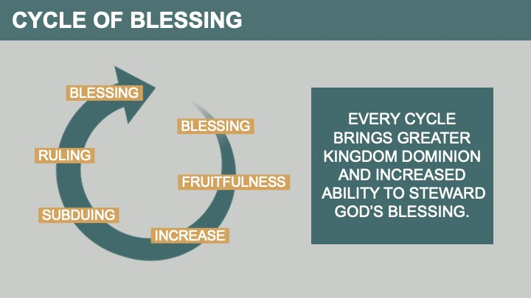
Purpose of Slide: God’s Kingdom Cycle of Blessing – Genesis 1:28
Trainer’s Notes: Every cycle brings greater kingdom dominion and increased ability to steward God’s blessing.
- Blessing
- Fruitfulness
- Increase
- Filling
- Subduing
- Ruling
- Blessing
_____________________________________________________________________

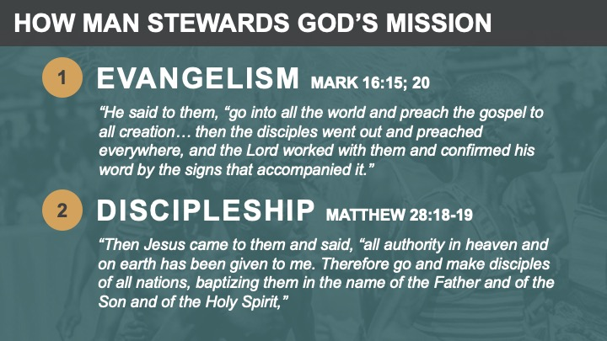
Purpose of Slide: God’s passion must work its way through our lives in daily stewardship of mission.
Main Thing: Only God can redeem, but He expects us to be involved in evangelism and discipleship. Since disciples always gather in some type of church, so church-planting should be an end result as well.
Trainer’s Notes:
- Evangelism – the announcement or proclamation – not truly separate from stewardship or discipleship, but contains a distinction, the announcement of the Kingdom on earth.
- Command is to go, preach; the target – every person “Into all the world” means “enter everyone’s world.”
- The command is to make disciples; the target – all ethne (i.e. people groups)! This is based upon the authority that Jesus gives us, exousia – “Delegated power of attorney.”
- Discipleship – involves teaching and training – a further step in evangelism.
- IMPORTANT – discipling leads to church planting.
NOTE: The gospel is the GOOD NEWS of the Kingdom. Always remember – it is good news. For this reason, the blessing and the news go together. We will see this further in Genesis 12:1-3 when we teach from that passage.
Illustration ideas: Share the starfish story
_____________________________________________________________________

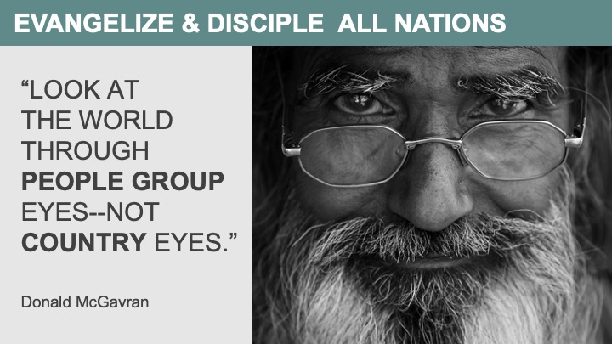
Purpose of Slide: Our task—focusing on people groups.
Main Thing: God looks at the world through “people group eyes.” He does not just see countries – He sees distinct people groups within countries.
Trainer’s Notes:
- The previous slide begs the question: Biblically speaking what are the nations and where do they come from?
- Here we introduce the concept of People Groups (PGs) as a BIBLICAL concept; People Groups are scriptural. We will later expand on the definition of ethne to show that this indeed fits the description of people groups.
- Read Genesis 11:4, 8-9. These verses reveal man’s two motivations for building a tower:
- To build a name for himself.
- That they do not get scattered over the whole earth.
- For our purposes we want to focus on reason #2 above. Why? Because it is a DIRECT violation of the “Kingdom” or “mission” mandate, to fill the earth.
- Man sought to disobey the mandate to fill the earth as God’s regents.
- The different languages gave birth to the “family of nations.” It is our contention that different cultures, nations, and tongues were part of God’s plan from the very beginning. (Not only a sign of judgment). The means by which He accomplished it was based on humankind’s condition and choices.

_____________________________________________________________________

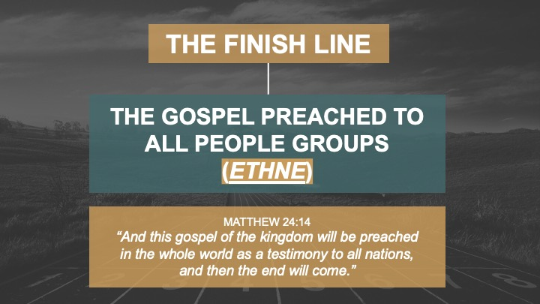
Purpose of Slide: How do we reach the finish line?
Main Thing: We do not “finish” until all the ethne have a chance to hear.

Trainer’s Notes:
- Matthew 24:14 – “And this gospel of the kingdom will be preached in the whole world as a testimony to all nations, and then the end will come.”
- We drift, even go sideways and backwards, if we don’t keep a clear vision of the finish line.
- We are commanded to make disciples of all the people groups. This is the foundation of the Great Commission mandate.
- Our principle target is not countries or only humanitarian projects, it is the evangelization of unreached people groups.
- Example: John Akhuari (the Tanzanian marathon runner)
- Ran the marathon in the 1968 Mexico City Olympics
- He became dehydrated, pulled a hamstring, and fell to the tarmac.
- Although he was injured and limping, he kept running.
- The winner and all the other runners that finished were announced.
- Then, someone called out “There’s another runner coming.”
- It was John Akhuari – he limped around the Olympic stadium track, and they put the victory ribbon up one more time. John broke it and everyone cheered.
- The reporters asked him afterwards, “Why would you endure such pain?”
- He said, “I represent my country of Tanzania. They sent me to finish the race, not just start it.”
- He was an ambassador – We are ambassadors too – of God’s Kingdom!

_____________________________________________________________________

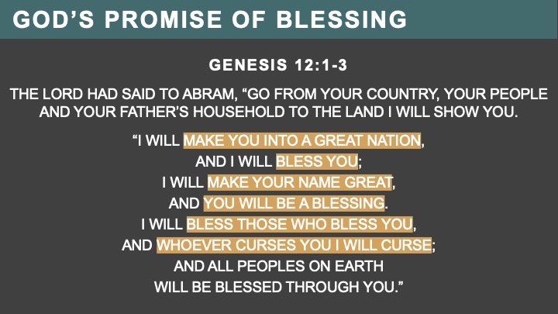
Purpose of Slide: God’s Promise of Blessing – as Abraham was blessed to be missionary father of the nation of Israel, we are blessed to take the Gospel to the ends of the earth.
Trainer’s Notes:
- WHY DO WE SAY THIS? WHY IS THIS IMPORTANT?
- Blessing – Seed of Mission – take note in Genesis 1:28 and 12:1-3 – God initiates with a blessing and then gives a mandate. That is not to say that the blessing is primarily pragmatic in nature (i.e. God is not blessing us just so He can merely use us to accomplish his will). Rather, contained in His desire to bless us and relate to us there is a purpose, a mission in which He invites us to participate.
- The blessing is primarily a means to an end!
- The blessing is never meant to stop with the recipient – this is a key element to the gospel. God’s blessing empowers us to be a blessing to the “others.” This is abundantly evident in the life of the patriarchs, Israel, David, Jesus, and the global church.
- In Genesis12:1-3, there are six ways God promised to bless Abraham’s lineage. We call this the “top line” of a contract. The “bottom line” of the contract is that the six top line blessings must be “funneled out” to “all peoples on earth.” “Peoples” in the Septuagint is “ethne.”
- The promise of Genesis 12:1-3 is also quoted in Genesis 18:18; 22:18; 26:4; 28:14; Psalms 72:17; and Acts 3:25, as well as here in Galatians 3:8-9:
- Make you into a great nation.
- Bless you.
- Make your name great.
- Make you a blessing.
- Bless those who bless you.
- Curse whoever curses you.
- Now, every believer and every church are to be part of a mission force to complete the Great Commission.
- There is no “real” Gospel without the Great Commission.
- Genesis 12:1-3 is a covenant from God to bless Abraham. God also blesses us as he did with Abraham. We are blessed in six ways as in the “top line of a contract.”

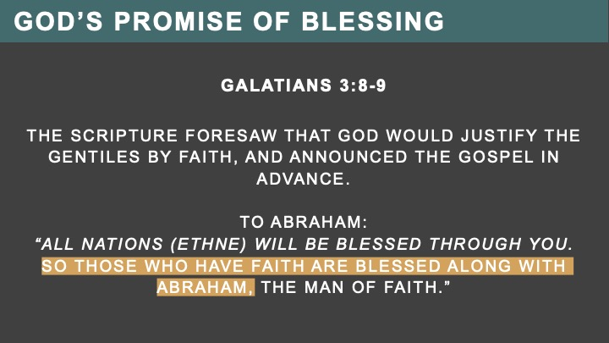
Purpose of Slide: Paul calls Galatians 3:8-9 – The “Gospel in Advance.” So, we see the heart of the Gospel is taking the message God’s love and blessings to all the nations (people groups) on earth. The Great Commission is part of the Gospel!
Trainer’s Notes:
- We are blessed by this covenant as well – Galatians 3:8-9
- We receive blessings to be a channel of blessings to every people group.

_____________________________________________________________________

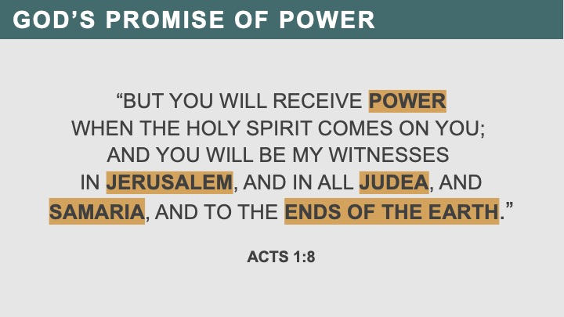
Purpose of Slide: This slide is vital. God has given power for all 4 areas. But so far, students don’t know about 4 areas, so emphasize that God has given them power not only for their Jerusalem, but all 4 areas simultaneously.
Acts 1:8 is the simultaneous scope of the Great Commission. All four cultural dimensions are the target for every believer and every church.
Main Thing: We are empowered to reach all four cultural dimensions and distances. Remember, distance is not miles/kilometers, but culture. Read Acts 1:8.
Trainer’s Notes:
- The promise of power – to project this witness to the ends of the earth. He gives us His dynamic power (Greek dunamis) to accomplish His mandate.
- For greater emphasis:
  - Genesis 1:28 – all the earth
  - Genesis 12:1-3 – all the families, communities, and peoples of the earth
  - Matthew 28:19 – all people groups
  - Acts 1:8 – to the ends of the earth
- Again, the language is consistent throughout the Bible. We will see later that it is included in the prophecy of every tribe, language, people, nation – Revelation 5:9-10.
- This is a simplified definition of the target for our strategy = other cultures. Illustrations are needed at this point in order to depict what the “ends of the earth” cultures are – use the example of UPGs.
CAUTION: OUR emphasis in ministry and training is the ends of the earth. However, we must be careful in our instructions to not belittle or de-emphasize the local ministry of the church. Our calling is to mobilize the church for missions to the unreached people groups of the world. There are too few doing this, so we don’t apologize for our emphasis. Our word of caution is that we be sensitive to the situation we find ourselves in when we are presenting the training.
- Acts 1:8 – But you will receive power when the Holy Spirit comes on you; and you will be my witnesses in Jerusalem, and in all Judea and Samaria, and to the ends of the earth.
- Same Culture: People who are the same in their society, culture, and language – would “blend in” to be of the same worldview – Jerusalem and Judea
- JERUSALEM – Bringing conversion and renewal to people in our own church churches.
  - People of the same culture. In this context it means people just like us socially, culturally, and linguistically. Coming from our “neighborhood” or “city.”
- JUDEA – Ministry within one's own culture or geographic region.
  - People of a distant but similar culture. In this context, it means people who are like us, but distant from our Jerusalem.

- Cross-Cultural: Ministry to peoples and people groups of a different worldview, belief systems, values, and attitudinal sets, and possibly negative behavior toward the biblical messenger. In Acts 1:8 terminologies, this is ministry to Samaria and the Ends of the Earth.
- SAMARIA – Cross-cultural evangelism to a culture that is somewhat like our own, their worldview is very similar to our own, but still different – for example, Americans to Europeans.
  - People of a different but somewhat similar culture – socially, linguistically, and possibly ethnically. In the New Testament era, the Samaritans were ethnically half-Jew and half-Greek – avoided by Jews.
- ENDS OF THE EARTH – Evangelism that crosses significant cultural differences and enters a radically different worldview context.
  - Effectively, this includes all Unreached People Groups (UPGs). People of a substantially different culture – socially, linguistically, and possibly ethnically.
_____________________________________________________________________
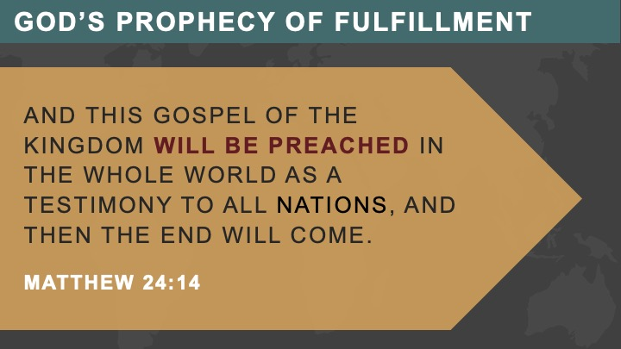
Purpose of Slide: Matthew 24:14 is both a promise and a prophecy. It will be fulfilled.
Main Thing: We can hasten the day or delay it as the result of our obedience or disobedience.
Trainer’s Notes:
- Once again, we are making abundantly clear that the mandate is to all the nations. What we want to say that this is a “given.” It will happen, it will be fulfilled.
- “The end will come” – this is “closure,” or completing the Great Commission in a measurable (quantity), observable (quality) manner, one UPG at a time.
_____________________________________________________________________

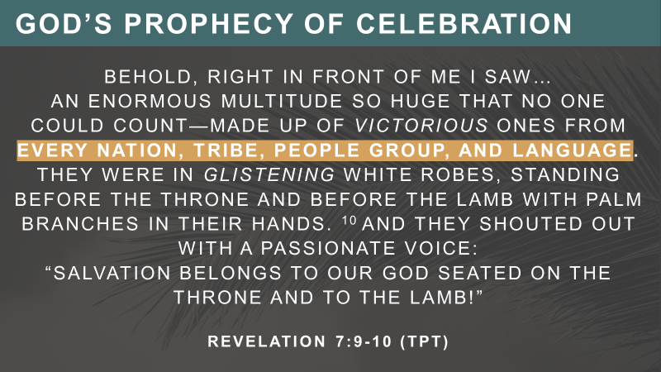
Purpose of Slide: Revelation 7:9-10 is a prophecy. It will be fulfilled.
Main Thing: We can hasten the day or delay it as the result of our obedience or disobedience.
Trainer’s Notes:
- Once again, we are making abundantly clear that the mandate is to all the nations. What we want to say that this is a “given.” It will happen, it will be fulfilled.
- “The end will come” – this is “closure,” or completing the Great Commission in a measurable (quantity) and observable (quality) manner – one UPG at a time.
- Etch this image in your heart. Give God your YES!

_____________________________________________________________________

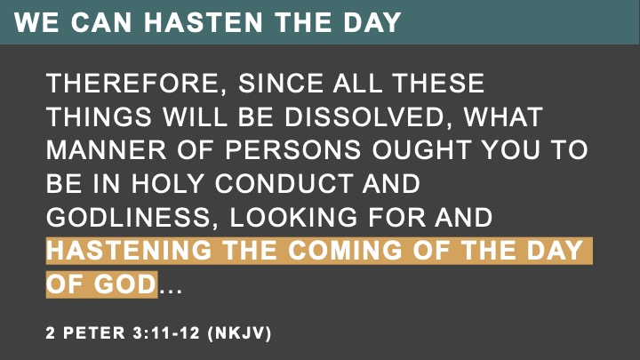
Purpose of Slide: We saw that Matthew 24:14 is both a promise and a prophecy. It will be fulfilled.
Main Thing: We can hasten (NIV – speed) the day or delay it as the result of our obedience or disobedience.
Trainer’s Notes:
- 2 Peter 3:11-12 – Read this text. It tells us that our holy and obedient lives will hasten or accelerate the coming of the day of God. This Greek word is properly translated as to hasten or accelerate.
- Σπεύδω – spey u doe – to set a-going, to urge on, hasten, quicken, speed.
- It is used when Jesus tells Zacchaeus to hasten down the tree; and is used again to indicate the quick pace at which Paul hastened his way back to Jerusalem so he wouldn’t miss the feast of Pentecost.
- This the nature of prophecy:
- God speaks something and we know, therefore, it will happen.
- However, He often plans these things in partnership with us.
- Thus, it is not merely going to happen, but we have a role of obedience to play in its fulfillment.
_____________________________________________________________________

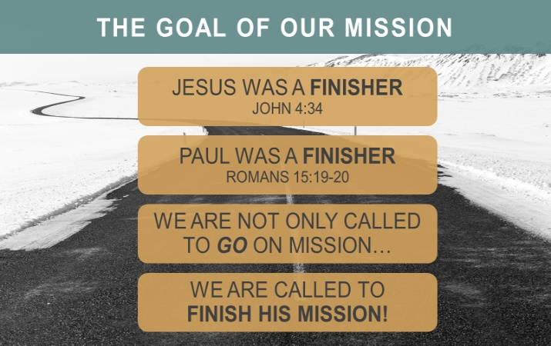
Purpose of Slide: If we are going to be like Jesus, we need to be finishers.
Main Thing: We don’t just go and do mission. Our objective is to finish what God pronounced in the Great Commission. This is an ITSM challenge – fulfilling, completing, and finishing the mission.
Trainer’s Notes:
- Jesus was a finisher. John 4:34 – “My food,” said Jesus, “is to do the will of him who sent me and to finish his work.”
- Paul was a finisher. He did not allow a co-dependent relationship to develop with the churches he planted. All his evangelism and church planting efforts were indigenous and sustainable.
- Emphasize the following two points throughout the training:
- The mission: coming of the Kingdom of God in the earth – common vocabulary in the scriptures.
- This mission: it is a doable and measurable task. We are called not to only engage the Great Commission, but we are called to finish it.
- Always begin with God’s end in mind. Thus, the end of our work is not merely to plant a certain number of churches among certain countries. Rather it is to see church planting movements among ALL the remaining UPGs: to finish the task, not just to engage them.
_____________________________________________________________________

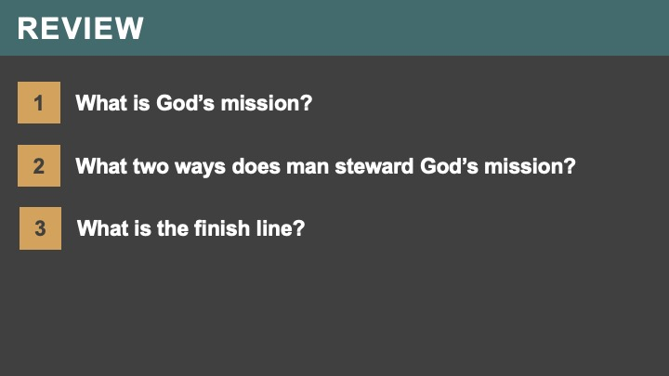
Purpose of Slide 13: Briefly review the main points learned from this session.
Trainer’s Notes: Have participants answer these questions out loud.)
- What is God’s mission?
- What two ways does man steward God’s mission?
- What is the finish line?

_____________________________________________________________________

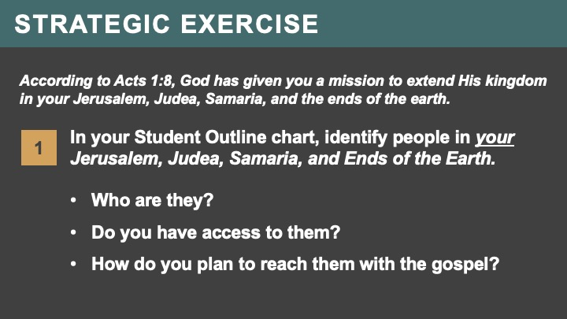
Purpose of Slide: Introduce the Strategic Exercise for Module 2.
Main Thing: According to Acts 1:8, God has given you a mission to extend His kingdom in your Jerusalem, Judea, Samaria, and the ends of the earth.

Trainer’s Notes:
- Identify the people in your Jerusalem, Judea, Samaria, and Ends of the Earth?
- Here are some questions to ask yourself:
  - Who are you already praying for?
  - Who do you have the ability to reach?
  - Who do you find yourself gravitating towards?
- Fill in the chart in your Student Outline
- Who are they?
- Do you have access to them?
- How do you plan to reach them with the gospel?
 | Who are they? | Do you have access to them? | How do you plan to reach them with the gospel?
Jerusalem
Judea
Samaria
Ends of the Earth

